Holy Week

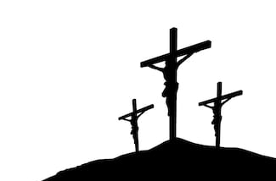

We are about to enter the most important week of the Christian year – Holy Week. Of course, I am sad that we will not be together in person to be able to follow the journey of Christ from the triumph of Palm Sunday, through the deceit of Maundy Thursday and to the degradation of the Cross on Good Friday. For only then will we be able to rejoice on Easter Sunday and join in the traditional refrain of the Church. Alleluia, Christ is Risen. HE IS RISEN INDEED. ALLELUIA!

One of the advantages of walking the dogs; what a blessing Dilys and Wilma are, is that it does give space to think; even when listening to the news of the day. In this period of lockdown, we are very much in a time of waiting. I was reminded of a devotional book I have on my shelves by W.H.Vanstone, “The Stature of Waiting”. In this illuminating book he sees in the Passion of Christ, the figure of Jesus as one who waits; and who in his waiting discloses the deepest dimension of the glory of God. We tend not to like waiting, but we are going to have to. The situation of waiting is generally resented; it is regarded as frustrating. But Vanstone asks if we can see in our waiting the image of God within us; so, in the end the waiting figure (both Jesus and ourselves) appears as a figure of extraordinary importance and remarkable dignity. As we wait, even as we feel increasingly cast aside, like Jesus in Holy Week, we can and will receive from Almighty God.

We have already circulated a series of readings for Holy Week in the Newsletter, alongside a Maundy Thursday, Good Friday and Easter Day services, but below are some links, for those who have access to a computer, further resources for Holy Week.

The first from the Singing the Faith plus website expands on the readings for the week, and offers further reflection.

https://www.methodist.org.uk/our-faith/worship/singing-the-faith-plus/posts/holy-week-a-singing-the-faith-introduction/

The second is from Wesley House in Cambridge, a series of acts of worship and lectures.
https://www.wesley.cam.ac.uk/about/whats-on/holy-week/
With every blessing
Yours in Christ
Rob

